Lab - 4

1.

Code :-

namespace Program

{

    class MainClass

    {

        public static void Main(String[] argv)

        {

            EmployeeData.Employee employee1 = new EmployeeData.Employee("Smit", "Shah", 100000.00);

            EmployeeData.Employee employee2 = new EmployeeData.Employee("Harsh", "Patel", 250000.00);

            //details of employee 1 & employee 2

            Console.WriteLine("-----------Yearly Salary Of Employees----------- \n");

            Console.WriteLine($"-------First Employee-------  \nYearly Salary : Rs.{employee1.MonthlySalary * 12}");

            Console.WriteLine($"-------Second Employee------- \nYearly Salary : Rs.{employee2.MonthlySalary * 12}");

            //giving 10% raise to employee

            employee1.getRaise(10);

            employee2.getRaise(10);

            Console.WriteLine("\n-----------Yearly Salary Of Employees After Giving 10%Raise-----------\n");

            Console.WriteLine($"-------First Employee-------  \n\nYearly Salary : {employee1.MonthlySalary * 12}");

            Console.WriteLine($"-------Second Employee------- \n\nYearly Salary : {employee2.MonthlySalary * 12}");

            //permanent Employees Derived Class

            EmployeeData.PermanentEmployee permanentEmployee1 = new EmployeeData.PermanentEmployee("Smit", "Shah", 100000.00, "14-02-2022", "20-12-2032");

            EmployeeData.PermanentEmployee permanentEmployee2 = new EmployeeData.PermanentEmployee("Harsh", "Patel", 250000.00, "14-02-2022", "06-12-2042");

            Console.WriteLine("\n\n-----------For Permanent Employees-----------");

            Console.WriteLine("\n-------Details Of Permanent Employee 1-------\n");

            Console.WriteLine(permanentEmployee1);

            Console.WriteLine("\n-------Details Of Permanent Employee 2-------");

            Console.WriteLine(permanentEmployee2);

            //giving 20% raise

            permanentEmployee1.getRaise(20);

            permanentEmployee2.getRaise(20);

            Console.WriteLine("\n\n-----------After Giving 20% Raise-----------");

            Console.WriteLine("\n-------Details Of Permanent Employee 1-------\n");

            Console.WriteLine(permanentEmployee1);

            Console.WriteLine("\n-------Details Of Permanent Employee 2-------");

            Console.WriteLine(permanentEmployee2);

        }

    }

}

using System;

namespace EmployeeData

{

    class Employee

    {

        public string _firstName;

        public string _lastName;

        public double _monthlySalary;

        //creating getter and setter properties

        public string FirstName

        {

            get => _firstName;

            set => _firstName = value;

        }

        public string LastName

        {

            get => _lastName;

            set => _lastName = value;

        }

        public double MonthlySalary

        {

            get => _monthlySalary;

            set

            {

                if (value < 0)

                    value = 0.0;

                _monthlySalary = value;

            }

        }

        //constructor

        public Employee(string firstName, string lastName, double monthlySalary)

        {

            _firstName = firstName ?? throw new Exception();

            _lastName = lastName ?? throw new Exception();

            _monthlySalary = monthlySalary;

        }

        //creating overridable method giveRaise()...

        public virtual void getRaise(double raise)

        {

            _monthlySalary += _monthlySalary * (raise / 100);

        }

        //overriding ToString from object class

        public override string ToString()

        {

            return $"Employee Name : {_firstName} {_lastName}  \nMonthly Salary : Rs.{_monthlySalary}";

        }

    }

    class PermanentEmployee : Employee

    {

        private double _hra;

        private double _da;

        private double _pf;

        string _joiningDate;

        string _retirementDate;

        public PermanentEmployee(string firstName, string lastName, double monthlySalary, string joiningDate, string retirementDate) : base(firstName, lastName, monthlySalary)

        {

            _da = base._monthlySalary * 0.12;

            _hra = (_da + _monthlySalary) * 0.05;

            _pf = _da;

            _joiningDate = joiningDate;

            _retirementDate = retirementDate;

        }

        //setting only read only properties

        public double HRA

        {

            get => _hra;

        }

        public double DA

        {

            get => _da;

        }

        public double PF

        {

            get => _pf;

        }

        public override void getRaise(double raise)

        {

            base.getRaise(raise);

            _monthlySalary += _hra + _da;

        }

        public override string ToString()

        {

            return $"{base.ToString()}\nJoining date: {_joiningDate}\nRetirement date:{_retirementDate}";

        }

    }

}

Output :- 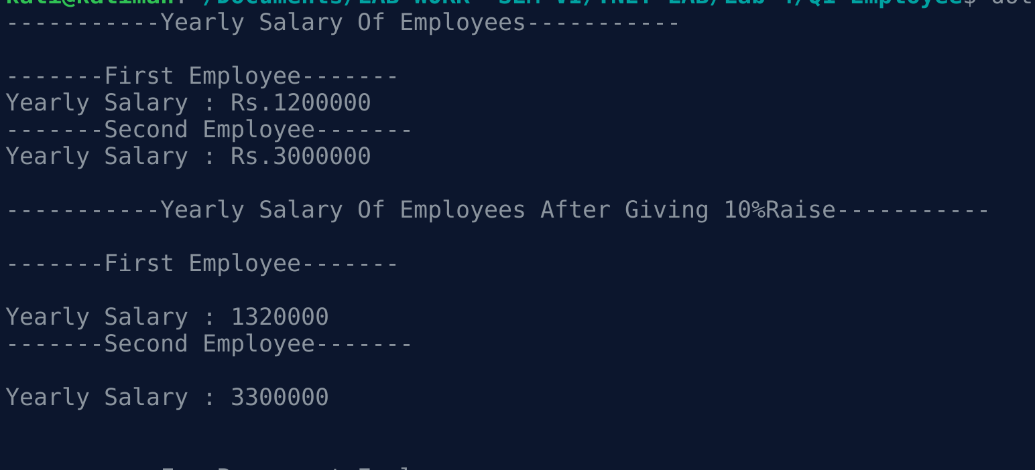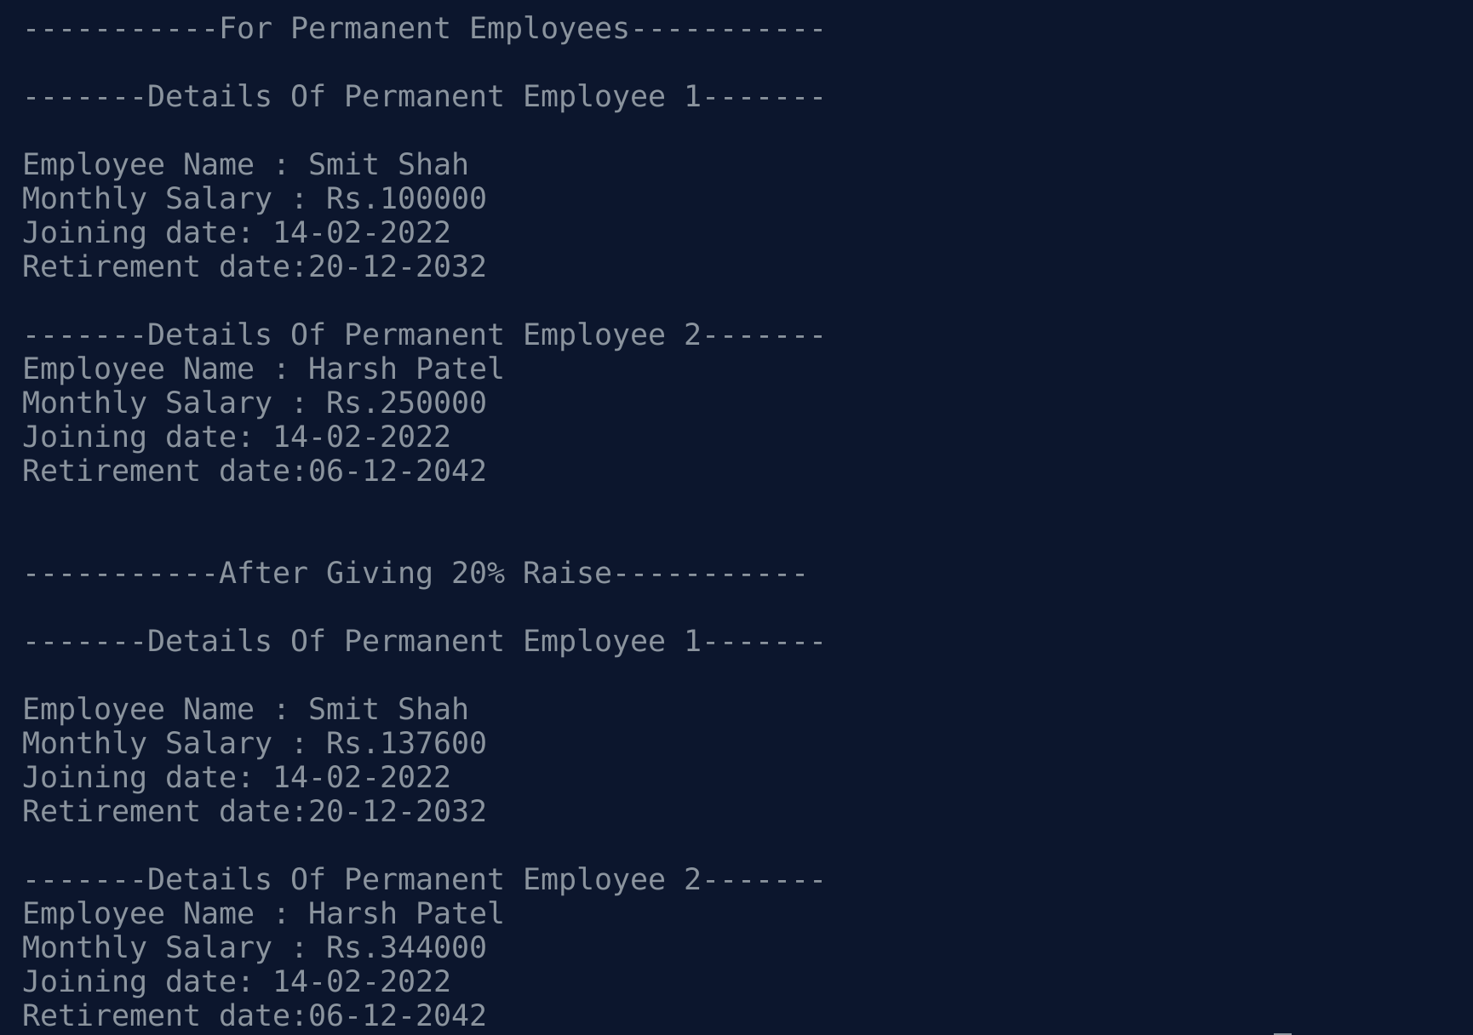

2.

Code :-

using System;

using Indexers;

namespace MainProgram

{

    class Program

    {

        public static void Main(string[] args)

        {

            //example-1

            var tempRecord = new TempRecord();

            tempRecord[3] = 58.3F;

            tempRecord[5] = 60.1F;

            for (int i = 0; i < 10; i++)

            {

                Console.WriteLine($"Element #{i} = {tempRecord[i]}");

            }

            //example-2

            var week = new DayCollection();

            Console.WriteLine(week["Fri"]);

            try

            {

                Console.WriteLine(week["Made-up day"]);

            }

            catch (ArgumentOutOfRangeException e)

            {

                Console.WriteLine($"Not supported input: {e.Message}");

            }

            //example-3

            var week2 = new DayOfWeekCollection();

            Console.WriteLine(week2[DayOfWeek.Friday]);

            try

            {

                Console.WriteLine(week2[(DayOfWeek)43]);

            }

            catch (ArgumentOutOfRangeException e)

            {

                Console.WriteLine($"Not supported input: {e.Message}");

            }

        }

    }

}

using System;

using Day = System.DayOfWeek;

namespace Indexers

{

    public class TempRecord

    {

        float[] temps = new float[10]

     {

        56.2F, 56.7F, 56.5F, 56.9F, 58.8F,

        61.3F, 65.9F, 62.1F, 59.2F, 57.5F

     };

        public int Length => temps.Length;

        public float this[int index]

        {

            get => temps[index];

            set => temps[index] = value;

        }

    }

    class DayCollection

    {

        string[] days = { "Sun", "Mon", "Tues", "Wed", "Thurs", "Fri", "Sat" };

        public int this[string day] => FindDayIndex(day);

        private int FindDayIndex(string day)

        {

            for (int j = 0; j < days.Length; j++)

            {

                if (days[j] == day)

                {

                    return j;

                }

            }

            throw new ArgumentOutOfRangeException(

                nameof(day),

                $"Day {day} is not supported.\nDay input must be in the form \"Sun\", \"Mon\", etc");

        }

    }

    class DayOfWeekCollection

    {

        Day[] days =

        {

        Day.Sunday, Day.Monday, Day.Tuesday, Day.Wednesday,

        Day.Thursday, Day.Friday, Day.Saturday

    };

        // Indexer with only a get accessor with the expression-bodied definition:

        public int this[Day day] => FindDayIndex(day);

        private int FindDayIndex(Day day)

        {

            for (int j = 0; j < days.Length; j++)

            {

                if (days[j] == day)

                {

                    return j;

                }

            }

            throw new ArgumentOutOfRangeException(

                nameof(day),

                $"Day {day} is not supported.\nDay input must be a defined System.DayOfWeek value.");

        }

    }

}

Output:-

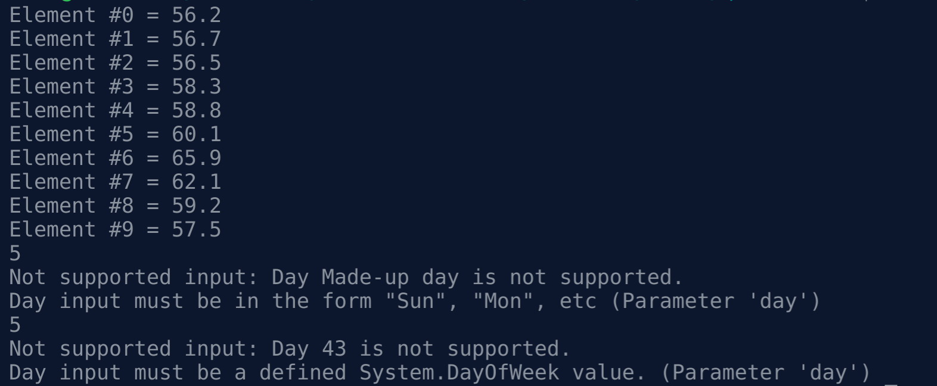

3.

Code:-

using System;

class TimePeriod

{

    private double _seconds;

    public double Hours

    {

        get { return _seconds / 3600; }

        set

        {

            if (value < 0 || value > 24)

                throw new ArgumentOutOfRangeException($"{nameof(value)} must be between 0 and 24");

            _seconds = value * 3600;

        }

    }

}

public class SaleItem

{

    string _name;

    decimal _cost;

    public SaleItem(string name, decimal cost)

    {

        _name = name;

        _cost = cost;

    }

    public string Name

    {

        get => _name;

        set => _name = value;

    }

    public decimal Price

    {

        get => _cost;

        set => _cost = value;

    }

}

public class SaleItems

{

    public string Name

    { get; set; }

    public decimal Price

    { get; set; }

}

class Program

{

    static void Main()

    {

        TimePeriod t = new TimePeriod();

        t.Hours = 24;

        Console.WriteLine($"Time in hours : {t.Hours}");

        var item = new SaleItem("Shoes", 19.95m);

        Console.WriteLine($"{item.Name}: sells for {item.Price:C2}");

        var newItem = new SaleItems { Name = "Shoes", Price = 19.95m };

        Console.WriteLine($"{newItem.Name}: sells for {newItem.Price:C2}");

    }

}

Output :-

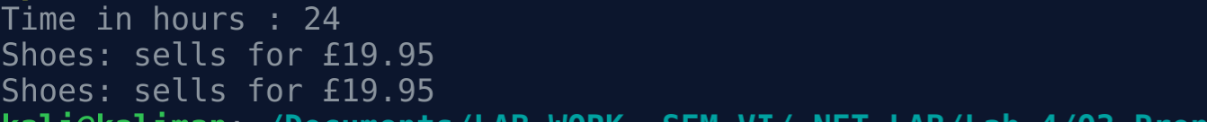

4.

Code :-

using System;

using System.Reflection;

public class SampleClass

{

}

public class SimpleClassExample

{

    public static void Main()

    {

        Type t = typeof(SampleClass);

        BindingFlags flags = BindingFlags.Instance | BindingFlags.Static | BindingFlags.Public |

                             BindingFlags.NonPublic | BindingFlags.FlattenHierarchy;

        MemberInfo[] members = t.GetMembers(flags);

        Console.WriteLine($"Type {t.Name} has {members.Length} members: ");

        foreach (var member in members)

        {

            string access = "";

            string stat = "";

            var method = member as MethodBase;

            if (method != null)

            {

                if (method.IsPublic)

                    access = " Public";

                else if (method.IsPrivate)

                    access = " Private";

                else if (method.IsFamily)

                    access = " Protected";

                else if (method.IsAssembly)

                    access = " Internal";

                else if (method.IsFamilyOrAssembly)

                    access = " Protected Internal ";

                if (method.IsStatic)

                    stat = " Static";

            }

            var output = $"{member.Name} ({member.MemberType}): {access}{stat}, Declared by {member.DeclaringType}";

            Console.WriteLine(output);

        }

    }

}

Output :-

